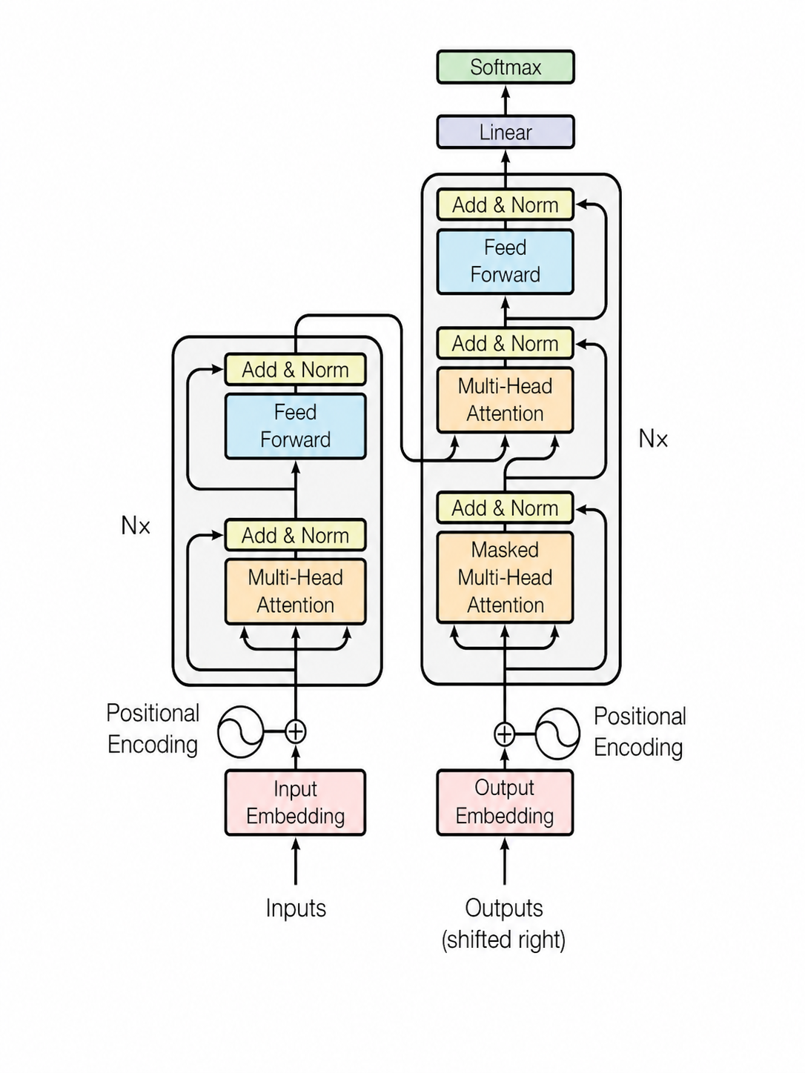

Encoder Side

1. Input Embedding
Converts each input token (word/subword) into a dense vector representation.
These embeddings capture semantic meaning so the model can process language numerically.

2. Positional Encoding
Adds positional information to embeddings because Transformers do not process tokens sequentially like RNNs.
It helps the model understand token order such as first word, second word, etc.

3. Multi-Head Attention
Allows the encoder to focus on different words of the sentence simultaneously.
Multiple attention heads learn different relationships like grammar, context, and semantic dependency.

4. Add & Norm
Performs residual connection followed by layer normalization.
This stabilizes training and helps prevent vanishing gradient problems in deep networks.

5. Feed Forward
A fully connected neural network applied independently to each token.
It helps the model learn more complex feature transformations after attention.

6. Nx
Indicates that the encoder block is repeated N times.
Stacking multiple layers allows deeper contextual understanding.

Decoder Side

7. Output Embedding
Converts previously generated output tokens into vector embeddings.
These embeddings are used by the decoder to predict the next token.

8. Positional Encoding
Adds order information to decoder input tokens.
This ensures the decoder understands token positions during generation.

9. Masked Multi-Head Attention
Prevents the decoder from seeing future words during training.
This ensures autoregressive generation where prediction depends only on past tokens.

10. Add & Norm
Again applies residual connection and normalization after masked attention.
This improves gradient flow and training stability.

11. Multi-Head Attention (Encoder-Decoder Attention)
Allows the decoder to attend to encoder outputs.
This connects input sentence understanding with output generation.

12. Feed Forward
Processes decoder representations through dense neural layers.
It refines token-level features before final prediction.

13. Linear
Projects decoder output vectors into vocabulary-sized logits.
Essentially converts hidden representations into word prediction scores.

14. Softmax
Converts logits into probability distributions over the vocabulary.
The token with highest probability is selected as the next generated word.

Extra Important Concept

15. Outputs (shifted right)
During training, decoder inputs are shifted by one position.
This teaches the model to predict the next token based on previous tokens only.
Residual connection means the model does not only use the transformed output of a layer, it also directly keeps the original input and adds it back later.
Mathematically:
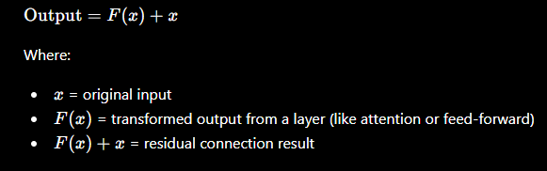
In Simple Words -
Instead of saying: “Forget the original input, only use the new transformed data”
The Transformer says: “Use the transformed data, but also preserve the original information.”
That preserved shortcut path is called the residual connection or skip connection.

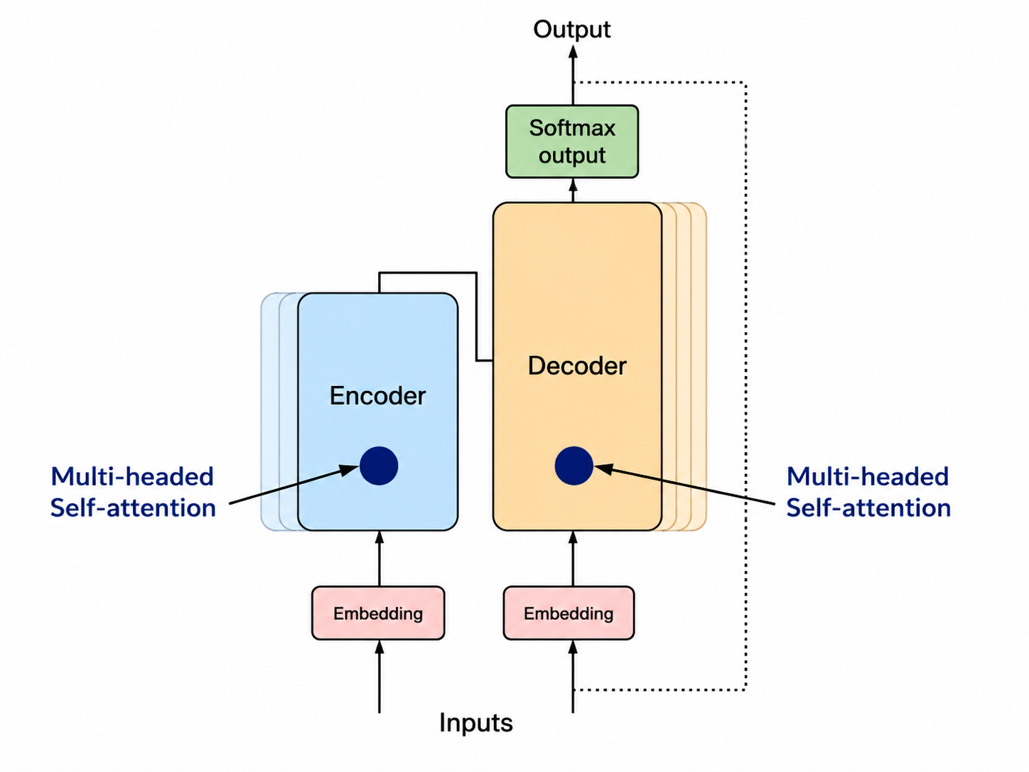

Encoder:
The encoder reads the entire input sentence and converts it into contextual representations.
It understands relationships between all words before passing information to the decoder.

Logistics Example -
Suppose TSP email says:
Truck is waiting for unloading at Hamburg warehouse since morning
Encoder understands:
- “truck” relates to logistics object
- “waiting for unloading” indicates scenario intent
- “Hamburg warehouse” is location context
So the encoder builds semantic understanding of the whole email.

Decoder:
The decoder generates the output token by token using encoder information.
It predicts the next word while considering previously generated words.
Logistics Example-
After encoder understands the email, decoder may generate:
Scenario = Unloading
The decoder creates this response sequentially.

Embedding:
Embedding converts words into dense numerical vectors.
Similar words get similar vector representations in high-dimensional space.

Logistics Example
Words like:
truck, shipment, carrier, transport
will have nearby vector meanings because they belong to logistics context.

Similarly:
delay, waiting, hold, pending
may cluster semantically.

Multi-Head Self-Attention:
Self-attention allows each word to look at other words in the same sentence.
Multi-head means multiple attention mechanisms learn different relationships simultaneously.

Logistics Example
Email:
Truck reached warehouse but unloading has not started
One attention head may focus on:
- Truck ↔ warehouse
Another may focus on:
- unloading ↔ not started
Another may focus on:
- temporal relationship
This is why Transformers understand context very well.

Softmax:
Softmax converts raw prediction scores into probabilities.
The highest probability token becomes the output prediction.

Logistics Example
Model logits:
Loading = 2.1
Unloading = 8.7
WH slot = 1.2
After Softmax:
Waiting for Unloading = 97%
Model selects that scenario.

